Name: Shay Walker

Box #613

Professor Sabal

Cairn University School of Business

CIS122 Essentials of Networking

Project #4

**Project objective:**

Effectively and efficiently network map out a new or existing office space of 200ft by 75ft. The space needs to be equipped to handle at least 50 workstations not including executive offices and conference rooms. Also, a minimum of 4 printers and 7 media access points (routers) should be used in the map.

**Equipment used:**

|  |  |  |  |  |
| --- | --- | --- | --- | --- |
| Equipment Description | Vendor | Vendor Item # | Retail price | Actual price (if known) |
| 4 post open frame rack (x4) | MONOPRICE | 10672 | $442.77  ($1,771.08 for 4) | N/A |
| Fiber Optic Connector/Coupler LC Duplex Multimode | Ultra Spec Cables | B001OZMFJY | $16.95  ($33.90 for 2 packs of 5) | N/A |
| Fiber Optic Cable- multimode, duplex  1000Ft | Netconnex Computer | AX002NALS9OR | $280.00 | N/A |
| 16 port CAT 6 rated patch panel | The Telecom Spot | 519526 | $27.08 | N/A |
| 24 port CAT 6 rated patch panel (x2) | MONOPRICE | 7253 | $17.99  ($35.98) | N/A |
| CAT- 6 Ethernet: (2x) | Newegg | N82E16812228330 | 1000ft.  $127.99 |  |
| RJ-45 Connectors 50pkg (2x) | Newegg | N82E16812200789 | $19.99 |  |
| NETGEAR ProSAFE 16-Port Gigabit Ethernet Smart Managed Pro Switch, L2+/Layer 3 Lite, 10 SFP+, ProSAFE Lifetime Protection (XS716T) | Amazon | XS716T-100NES | $995.07 |  |
| Netgear XS724EM-100NAS 24-port 10-Gigabit / Multi-Gigabit Ethernet Smart Managed Plus Switch | 2 x 10G SFP+ Fiber ports | Rackmount | 24 x Multi-speed ports | ProSAFE (XS724EM) (2x) | Amazon | XS724EM-100NAS | $1699.99 |  |
| NETGEAR 8-Port Gigabit Ethernet Smart Managed Pro Switch, L2+/Layer 3 Lite, 10 SFP+, ProSAFE Lifetime Protection (XS708T) (2x) | Amazon | XS708T-100NES | $819.99 |  |
| AGM732FFIBER 1000BLX-GBIC MOD (8x) | Zones | 01223074 | $291.99 |  |
| UniFi AC HD (Ubiquity access point) | Uiquity | UAP-AC-HD | 5pkg = $1679.00 +  2 for $349.00 each |  |

**Detailed list of software and operating platforms used, including version numbers and licensing requirements:** N/A

**Network diagram:**

(See physical copy)

Pink Squares – Printers

Black spiked squares – drop

Yellow line – patch panel

Blue squares – Backbone switch

Red squares – non-backbone switch if necessary (8, 16, or 24 port)

Green squares – media access point (router)

Aqua blue line – CAT 6 Ethernet Cabling

Orange line- Fiberoptic Cabling

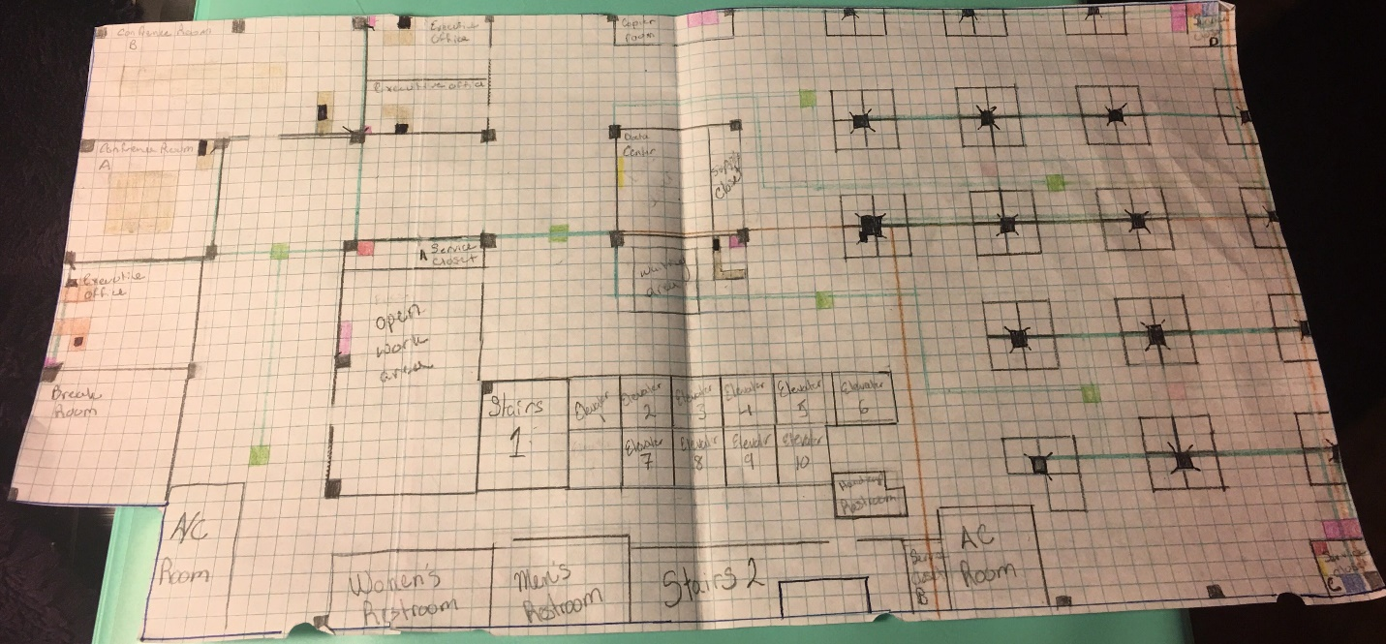

**Configurations:**

The Demarcation point is connected to the switch in the Data Center. The switch that is in the Data Center is connected to the back-bone switches through fiber optic cabling, which are then connected to the patch panels through CAT 6 (patch cables). All the drop points are using CAT 6 cabling and are connected to the patch panels. Routers are connected to the switch in the Data Center through CAT 6 Cabling.

Within the design of the floor plan I have accounted for 50 cubical work spaces as well as an open area work space for work to be done in an additional setting (Wi-Fi for laptops). These spaces could also be converted and rearranged as necessary or desired. There are three executive offices and two conference rooms accounted for. Each conference room has access to a drop for a work station. The executive offices have drops for a printer and workstation. The Media access points are spread out and overlap to ensure coverage in all areas needed. CAT 6 cabling was used to keep the wiring up to date as standards are now shifting toward making CAT 6 cabling the basis for wiring. Phones are daisy chained to the drops allowing for one drop to be needed for each computer and phone together. Room is available for the phones to be un-daisy chained, but daisy chaining is more cost effective.

DATA CENTER:

* Fire wall
* (2) 8 port switch with SPF compatibility
* (1) Rack

Media Access points connect to the Data Center

SERVICE ROOM A

* (1)16 port switch
* (1) 16 port patch panel
* It provides drops for 3 executive offices and conference rooms A and B

SERVICE ROOM B

* Demarcation point
* (1) 8 port switch that has an SPF port to run Fiber Optic to the Data Center

SERVICE ROOM C

* (1) 24 port patch panel
* (1) 24 switch
* Switch connects to the Data Center through fiber optic connection (SPF ports)

SERVICE ROOM D

* (1) 8 port switch
* (1) 24 port switch
* (1) 48 port patch panel
* Theses switches use the SPF ports to run back to the Data Center using Fiber optic cabling

*All Service rooms have a rack large enough to hold the necessary equipment

NOTES:

* A/C will be vented into the Data Center and heat will be vented outside
* Each workstation will have one port for telephone and computers (connection to the network). Phones and computers are on separate VLANs.
* No cables are daisy-chained; all are separate but may follow in a similar path.
* Small racks are holding the switches in the designated service closets.
* Run Labor = approx. 80 runs, with a set rate of $100 per run = $8,000
* CAT 6 cabling was used to ensure that the wiring would remain updated with equipment and proper standards